**UNIT-IV STRUCTURAL GEOLOGY**

**Strike and dip:** These are attitudes or characteristics in the rocks produced by geologic forces and present after the rocks are folded (bent) or faulted (cracked and moved along the crack appreciable distance)

**A. Strike:** Itis an imaginary line with compass direction constructed on the surface of a sedimentary bed or fault in which all points on that line are of equal elevation--the compass direction is usually expressed as a bearing

**B. Dip: It** is an imaginary line constructed down-slope on a sedimentary bed or fault--the dip direction is perpendicular to the strike direction and usually expressed in bearing and an angle of tilt (dip) measured from the horizontal plane to the top of a bed or fault--a dip angle may not exceed 90 degrees

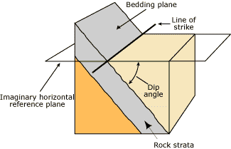

**Deformation**• The theory of plate tectonics tells us that the Earth’s plates are in constant motion  
• They move apart, collide and slide past one another

• As well as generating earthquakes and volcanoes these processes also deform the rocks of the crust*Many rocks have been deformed by dynamic forces that cause fracturing, folding, and faulting of rocks. Processes that cause deformation are associated with plate boundaries and mountain building processes.*  
**How Does Rock Deform?**

• Deformation is simply a change in shape and/or volume of rocks.

• We can measure these changes both in the field and the lab in order to try and understand  
how rocks deform

**Stress and strain**

• Stress is the force applied to a given area of rock.

• It has the same definition as pressure (*force acting on a surface per unit area*)  
• However, pressure is generally considered to be acting equally in all directions  
• So geologists use the term stress

• Differential stress

• Uniform stress

• Uniform stress can also be thought of as confining pressure or confining stress

**Stress comes in three ways:**

• Compression

• Tension

• Shear

**Compression**In compression, rocks are squeezed by external forces acting toward one another. Compression causes rock to shorten along the direction of compression. Compression causes folding as well as reverse and thrust faulting.

**Tension**Tension results from force acting in opposite directions, which tends to lengthen rocks and pull them apart. Tension causes normal faults.

**Shear**In shear stress, forces act opposite one another in a horizontal plane. Shear stress causes rocks to slip past one another in a horizontal plane as with strike-slip faults.

**Strain**• Strain also comes in three flavours

• Elastic strain

• Plastic strain

• Brittle strain

**Elastic deformation**

• This is a non permanent change in volume or shape

• A good example of this is a metal spring

**Elastic limit**

• Once the elastic limit is exceeded rocks will deform

• Ductile deformation is permanent

**Brittle deformation**

This occurs when rocks fracture rather than bend Brittleor ductile?

• The response to deformation is controlled by the nature of the stress, pressure, temperature, time and rock type

• Any rock under the great pressures and high temperatures of Earth’s interior is more ductile that it would be at Earth’s surface.

**Temperature**• Solids become more ductile and less brittle at high temperatures

• Glass can be blown when hot but will shatter when cold

• This is why the asthenosphere ‘flows” Confining pressure High confining pressure reduces  
brittleness by hindering fracture formation

**Rate of deformation**

• The rate at which stress is applied determines if the failure will be brittle or ductile

• Think of ‘silly putty’ - it bounces if dropped but shatters if hit with a hammer

• Strain rate - this is the rate at which a rock is deformed

• Low strain rate results in ductile behavior

• Low temperatures, low confining pressures and high strain rates result in brittle behavior

• High temperatures, high confining pressures and low strain rates result in ductile behavior

• Brittle-ductile transition - the point at which behaviour changes (~10-15 km)

**Deformation & Geologic Structures**

• Any feature resulting from rock deformation is a geologic structure, especially fractures, folds, and

faults.  
• Folding occurs in response to ductile deformation

• Faulting occurs in response to brittle deformation

• The study of these features is structural geology

**Brittle structures**

• Brittle failure results in fractures in a rock.

• These basically take two forms

• Joints are fractures in a rock along which no displacement has occurred.

• Faults are fractures along which blocks have moved parallel with the fracture surface

• Joints are generally small but pervasive

• Faults can vary from micro fractures to continent scale (San Andreas fault or East African Rift)

**Faults**Not all faults penetrate to the surface, but those that do often show a fault scarp, a  
cliff or bluff formed by vertical movement along the fault plane.

There is some *terminology* we must know to understand faults:

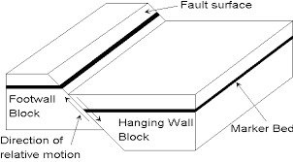• Fault plane (fault scarp)

• Hanging wall

• Footwall

**Hanging wall & footwall**

The hanging wall block lies above Fault types

and

The footwall block lies beneath the fault plane

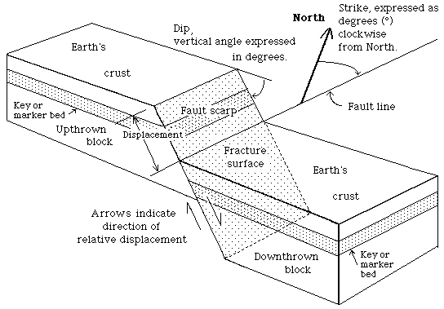

**Fault types**

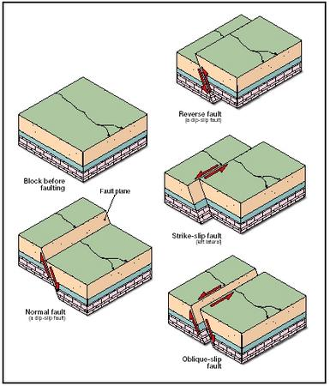**We can only think of the movement on faults in terms of relative movement, faults are**

• Normal or dip-slip faults

• Reverse faults

• Strike slip faults

• Oblique slip faults and some combination

**Normal or dip-slip faults**

• All movement on a dip-slip fault is parallel to the dip of the fault plane, that is, movement is up or down the fault plane.

• In a normal fault, *the* *hanging wall moves down the fault plane*. Normal faults result from tensional stress.

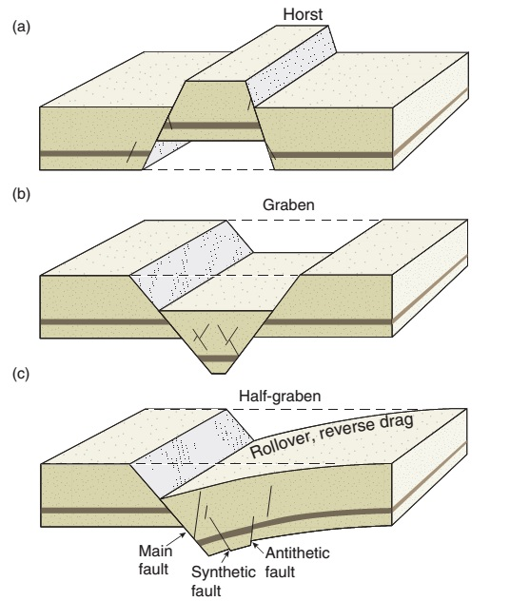

**Horst & Graben structures**

**Horst** uplifted block with faults dipping away**(a)**

**Graben** downthrown block with faults dipping  
towards each other **(b)**

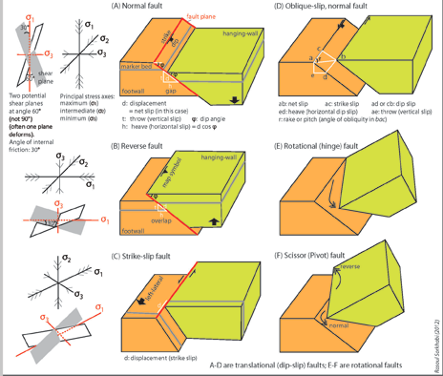

**Reverse** faults are dip-slip faults where the hanging wall has moved up the inclined fault plane. In reverse faults, the dip of the fault plane is >45°. Formed by compressional stress

**Thrust faults are** Reverse faults with fault plane dips of <45° are called thrust faults.

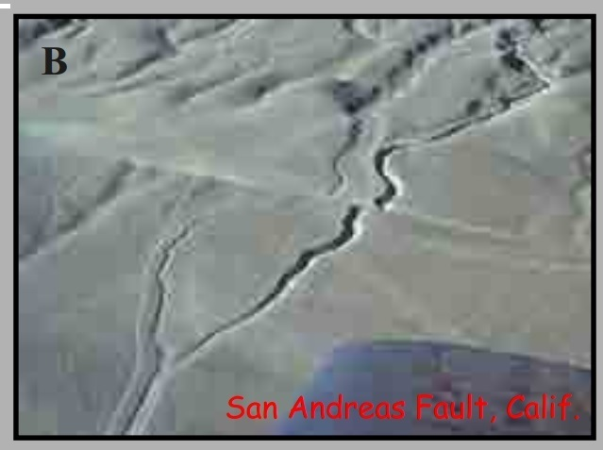**Strike-Slip Faults** Strike-slip faults are caused by shearing forces, which cause blocks on either side of the fault plane to slide laterally past one another.  
As the observer looks across the fault plane to the opposite side, the offset feature will  
lie to the left for a left lateral (sinistral) fault strike-slip fault, and to the right for a right lateral (dextral) strike slip fault.

**Example: San Andreas fault.** The Pacific plate appears to be moving NW relative to the North American plate

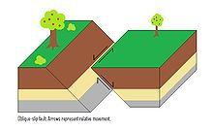

**Oblique slip** fault on which the movement is along both the strike and the dip of the fault.

**Joints**

A **joint** is a break ([fracture](https://en.wikipedia.org/wiki/Fracture_(geology))) of natural origin in the continuity of either a layer or body of [rock](https://en.wikipedia.org/wiki/Rock_(geology)) that lacks any visible or measurable movement parallel to the surface (plane) of the fracture. Although they can occur singly, they most frequently occur as joint sets and systems**.**

• These are formed in a variety of ways but are characterized by the fact that no movement has occurred along the fracture .

• Some form as a result of regional stress, others because of cooling or pressure release

• Joints can form in the upper parts of anticlines which undergo tension as the rocks flex around the fold axis. Joints form when rocks are stretched by simple tension or shear stress.

A **joint set** is a family of parallel, evenly spaced joints that can be identified through mapping and analysis of the orientations, spacing, and physical properties.

A **joint system** consists of two or more intersecting joint sets.

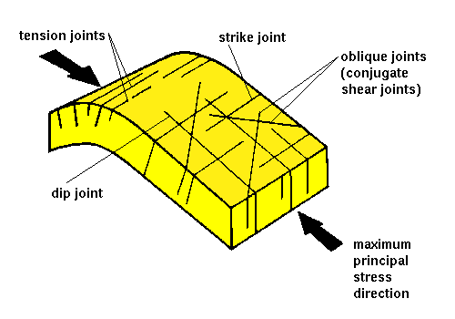

**Types of Joints**

Joints are classified either by the processes responsible for their formation or their geometry.

**Types of joints with respect to formation**

On the basis of their origin, joints have been divided into a number of different types that include tectonic, hydraulic, exfoliation, unloading (release), and cooling joints.

**Tectonic joints** are joints that formed when the relative displacement of the joint walls is normal to its plane as the result of brittle deformation of bedrock in response to regional or local tectonic deformation of bedrock. Tectonic joints occur as both nonsystematic and systematic joints, including orthogonal and conjugate joint sets.

**Exfoliation joints** are sets of flat-lying, curved, and large joints that are restricted to massively exposed rock faces in an deeply eroded landscape.  The vertical, gravitational load of the mass of a mountain-size bedrock mass drives longitudinal splitting and causes outward buckling toward the free air. In addition, paleostress sealed in the granite before the granite was unearth by erosion and released by exhumation and canyon cutting is also a driving force for the actual spalling.

**Unloading joints** or **release joints** are joints formed near the surface during uplift and erosion. As bedded sedimentary rocks are brought closer to the surface during uplift and erosion, they cool, contract and become relaxed elastically. This causes stress buildup that eventually exceeds the tensile strength of the bedrock and results in the formation of jointing. In the case of unloading joints, compressive stress is released either along preexisting structural elements (such as cleavage) or perpendicular to the former direction of tectonic compression.

**Cooling joints** are columnar joints that result from the cooling of either lava from the exposed surface of a lava lake or flood basalt flow or the sides of a tabular igneous, typically basaltic, intrusion. They exhibit a pattern of joints that join together at triple junctions either at or about 120° angles. They split a rock body into long, prisms or columns that are typically hexagonal, although 3-, 4-, 5- and 7-sided columns are relatively common. They form as a result of a cooling front that moves from some surface, either the exposed surface of a lava lake or flood basalt flow or the sides of a tabular igneous intrusion into either lava of the lake or lava flow or magma of a dike or sill.

**Hydraulic joints** are formed when pore fluid pressure became elevated as a result of vertical gravitational loading. In simple terms, the accumulation of either sediments, volcanic, or other material causes an increase in the pore pressure of groundwater and other fluids in the underlying rock when they cannot move either laterally of vertically in response to this pressure.

### Classification of joints by geometry

### The geometry of joints refers to the orientation of joints. In terms of geometry, three major types of joints, nonsystematic joints, systematic joints, and [columnar jointing](https://en.wikipedia.org/wiki/Columnar_jointing) are recognized.

**Nonsystematic joints** are joints that are so irregular in form, spacing, and orientation that they cannot be readily grouped into distinctive, through-going joint sets.

**Systematic joints** are planar, parallel, joints that can be traced for some distance, and occur at regularly, evenly spaced distances on the order centimeters, meters, tens of meters, or even hundreds of meters. As a result, they occur as families of joints that form recognizable joint sets. Typically, exposures or outcrops within a given area or region of study contains two or more sets of systematic joints, each with its own distinctive properties such as orientation and spacing, that intersect to form well-defined joint systems.

Within regions that have experienced tectonic deformation, systematic joints are typically associated with either layered or bedded strata that has been [folded](https://en.wikipedia.org/wiki/Fold_(geology)) into [anticlines](https://en.wikipedia.org/wiki/Anticline) and [synclines](https://en.wikipedia.org/wiki/Syncline). Such joints can be classified according to their orientation.

* *Longitudinal joints* – Joints which are roughly parallel to fold axes and often fan around the fold.
* *Cross-joints* – Joints which are approximately perpendicular to fold axes.
* *Diagonal joints* – Joints which typically occur as conjugate joint sets that trend oblique to the fold axes.
* *Strike joints* – Joints which trend parallel to the strike of the axial plane of a fold.
* *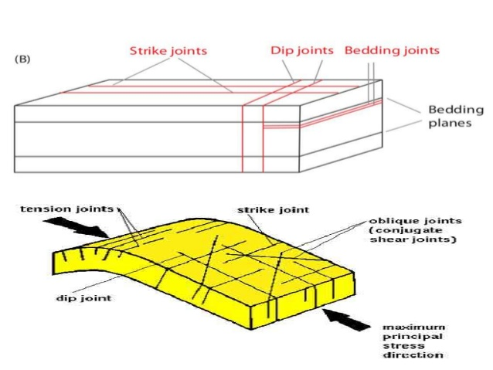Cross-strike joints* – Joints which cut across the axial plane of a fold.

**Strike joints:**The joints which are parallel to the strike of the rock bed is called strike joints.

**Dip joints:** The joints which are parallel to the dip of the rock bed is termed as dip joints.

**Oblique joints:**Joints which are neither parallel to the strike nor to the dip of the rock layer in which they occur is known as oblique joints.

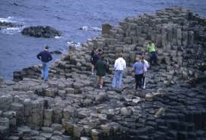**Bedding Joints:** In stratified rocks the joints may develop essentially parallel to the bedding planes are defined as bedding joints.

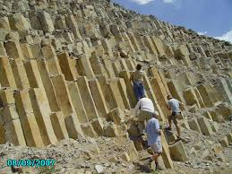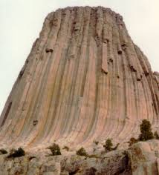**Columnar jointing** is a distinctive type of joints that join together at triple junctions either at or about 120° angles. These joints split a rock body into long, prisms or columns. Typically, such columns are hexangonal, although 3-, 4-, 5- and 7-sided columns are relatively common.

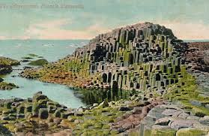

**Folds**

• When rocks deform in a ductile manner they bend and flow to form folds

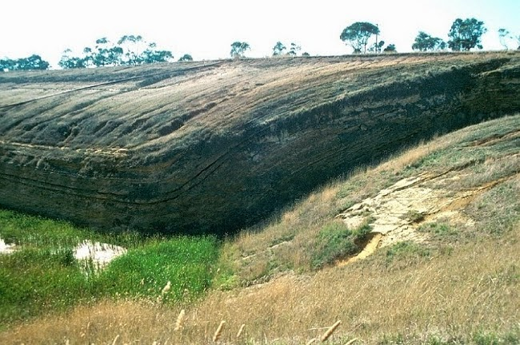• They range in scale from mm to km

• There are three basic fold types

• Monoclines

• Synclines

• Anticlines

**Monoclines** Monoclines are simple bends or flexures in otherwise horizontal or uniformly dipping layers. Monoclines often drape deep fractures in the rock along which vertical movement has occurred.

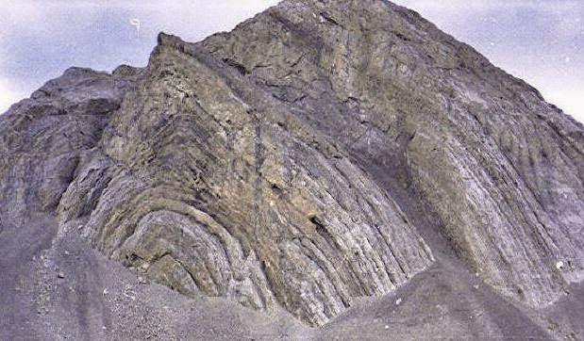

**Anticlines** Anticlines are arched or convex-upward folds with the oldest rocks in the core of the fold.

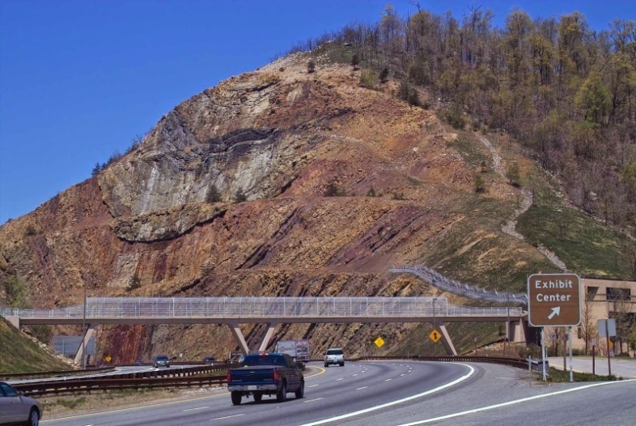

**Synclines:**Synclines are trough-like or concave downward folds with the youngest rocks in the core of the fold.

**Terminology of Folds**

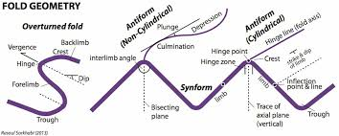**Folds**Anticlines and synclines do not necessarily correspond to highs and lows on Earth’s surface.

Anticlines and synclines often occur together in alternating series. Upright folds have vertical axial  
planes and limbs that dip at the same angle in opposite directions.

Folds with non-vertical axial planes and limbs that are in opposite directions and at different angles are inclined folds.

Folds with non-vertical axial planes and limbs that dip in the same directions, but at different angles are overturned folds.)

**Folded Rock Layers**

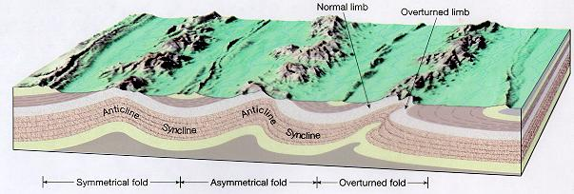Where deformation has been especially intense, folds sometimes have horizontal axial planes. These are recumbent folds. Overturned and recumbent folds are particularly common in mountain ranges formed by compression along convergent plate margins.

**Types of fold**

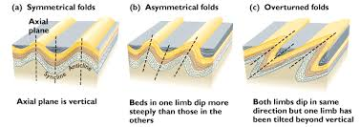

**Symmetrical Fold:** A fold which divides in to two half’s as mirror images by the axial plane is known as symmetrical fold

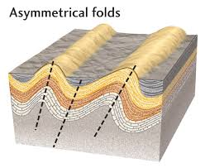

**Asymmetrical** **Fold:** If the axial plane devides the fold in to unequal parts is termed as asymmetrical fold

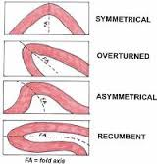

**Overturned Fold:**In a fold both the limbs dip in a same direction but one limb has been tilted beyond vertical is called as overturned fold

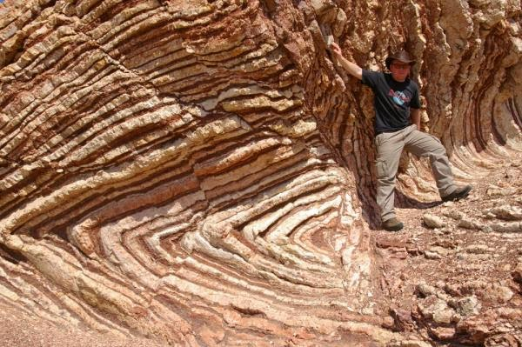

**Recumbent Fold :** Recumbent fold has an essentially horizontal axial plane. linear, fold axial plane oriented at low angle resulting in overturned strata in one limb of the fold.

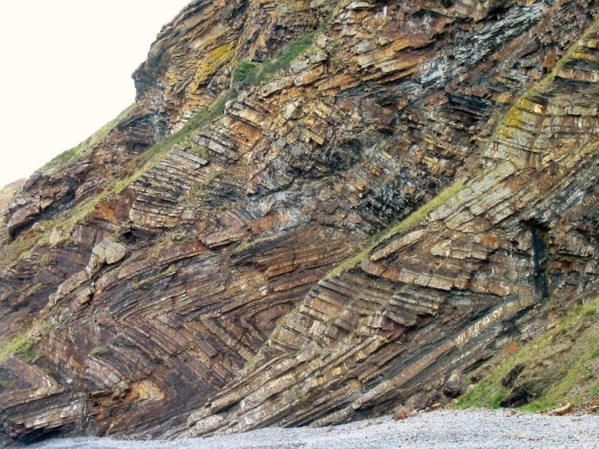

**Chevron Fold**Chevron folds are a structural feature characterized by repeated well behaved folded beds with straight limbs and sharp hinges. Well developed, these folds develop repeated set of v-shaped beds. They develop in response to regional or local compressive stress. Inter-limb angles are generally 60 degrees or less. Chevron folding preferentially occurs when the bedding regularly alternates between contrasting competences.

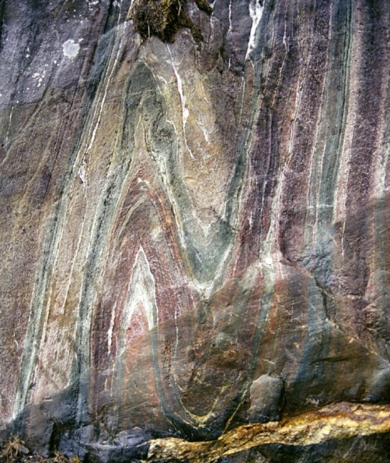

**Isoclinal fold:** Isoclinal folds are similar to symmetrical folds, but these folds both have the same angle and are parallel to each other. 'Iso' means 'the same' (symmetrical), and 'cline' means 'angle,' so this name literally means 'same angle.' So isoclinal folds are both symmetrical and aligned in a parallel fashion.

**[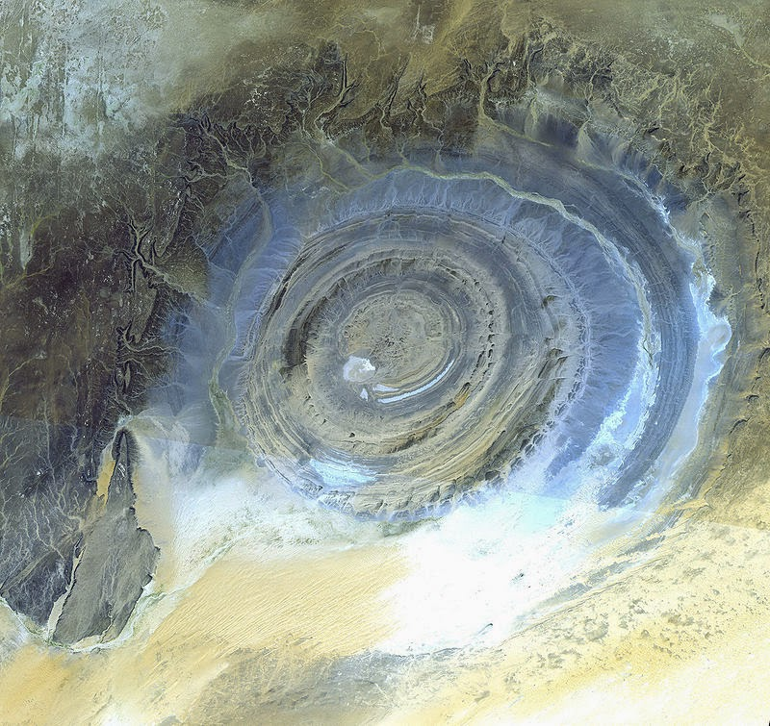](http://3.bp.blogspot.com/-3B2aZHHFYv4/VOtgHuOe0iI/AAAAAAAAEjI/lBHs5Euzd1w/s1600/Desert+of+Mauritania.+dome..jpg)**

**Dome and Basin**

We also have domes, which are like anticlines but instead of an arch, the fold is in a dome shape, like an inverted bowl. Similarly, there are also basins, which are like synclines but again, instead of a sinking arch, the fold is in a shape of a bowl sinking down into the ground. **Dome**: nonlinear, strata dip away from center in all directions, oldest strata in center. **Basin**: nonlinear, strata dip toward center in all directions, youngest strata in center.

• Domes and basins are circular- to oval-shaped folds.

• In eroded domes, the oldest rocks lie at the middle of a bull’s eye map pattern and all layers dip away from the center.

[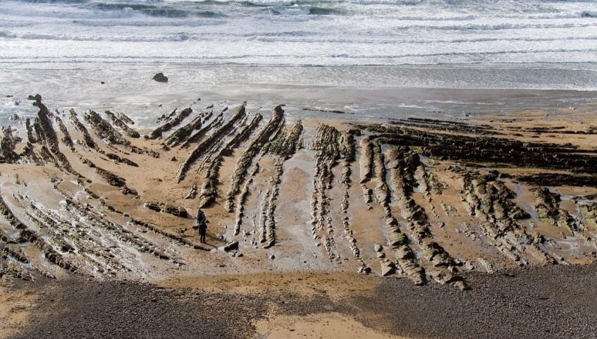](http://3.bp.blogspot.com/-gJeBwl30JDE/VOtaR-_gQeI/AAAAAAAAEi4/pV3gSII3m5U/s1600/Plunging+fold.jpg)• In basins the youngest rocks lie at the middle of a bull’s eye map pattern and all layers dip toward the center.

**Plunging fold :**A fold whose axis plane is not horizontal (not Parallel to sea level). Direction of plunge - the direction in which the axis is inclined nose - indicate the direction of plunge. In anticline, plunge is directed towards nose and in syncline it is directed away from nose.

• If a fold’s axis is not horizontal, the fold is plunging

• Anticlines have outcrop patterns that point in the direction of plunge.

• Synclines have map patterns that open in the direction of plunge.

• A series of alternating, plunging anticlines and syncline forms a zig-zag,   
or sawtooth map pattern.

**[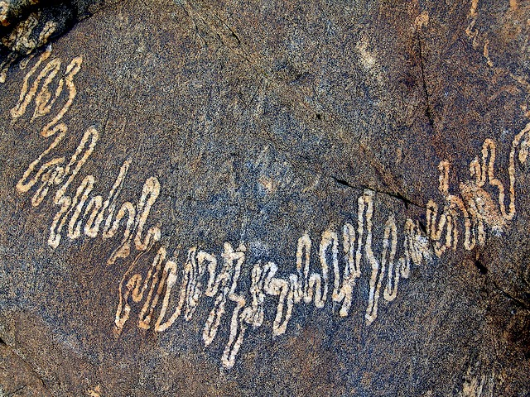](http://1.bp.blogspot.com/-DWh1f8q99PA/VOth3m3XkQI/AAAAAAAAEjU/T1g3zfaGvvA/s1600/2040914790_ac70e94514_z.jpg)Ptygmatic fold**

 Folds are chaotic, random and disconnected. Typical of sedimentary slump folding, migmatites and decollement detachment zones. Ptygmatic folds generally represent conditions where the folded material is of a much greater viscosity than the surrounding medium.

**ANTICLINORIUM AND SYNCLINORIUM**

A large or major anticline or a syncline on whose limbs are found minor folds, both anti- and synclines, generally asymmatrical and of opposite senses on the two limbs is known as anticlinorium and synclinorium respectively.

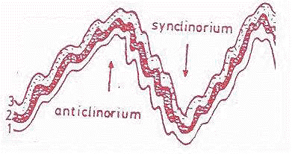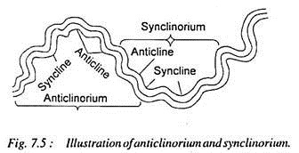

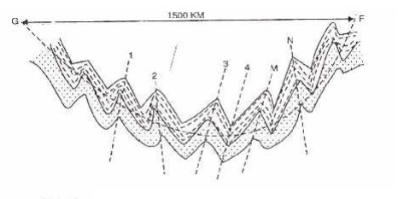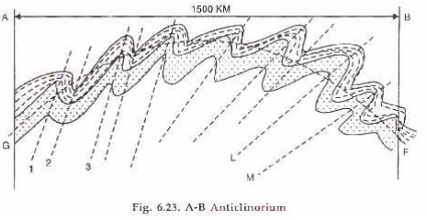

**ANTICLINORIUM SYNCLINORIUM**

**unconformities**

**Gaps in the record (**unconformities)

• If the geological record was complete we could determine an absolute age based on the thickness of sediments  
• This requires that the sedimentary record is conformable

• However, because sedimentation periodically stopped and there are periods of erosion this is not the case  
• These gaps are called unconformities

**Unconformities** **:**Majorly unconformaties are three types such aas

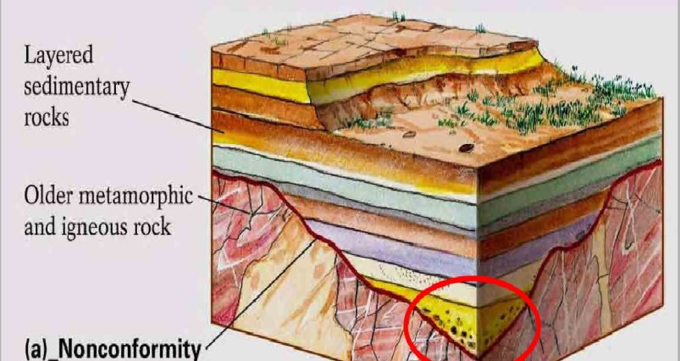**Non-Conformity:** An unconformity that separates crystalline rocks, either igneous or metamorphic, from sedimentary rocks is known as non-conformity.

A nonconformity exists between sedimentary rocks and [metamorphic](https://en.wikipedia.org/wiki/Metamorphic_rocks) or [igneous rocks](https://en.wikipedia.org/wiki/Igneous_rocks) when the sedimentary rock lies above and was deposited on the pre-existing and eroded metamorphic or igneous rock. Namely, if the rock below the break is igneous or has lost its bedding due to metamorphism, the plane of juncture is a nonconformity)

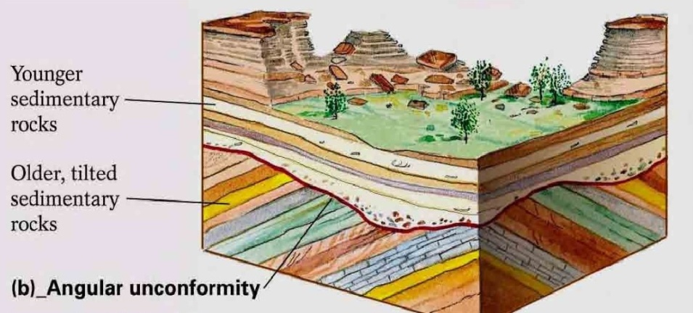**Angular unconformity:** An angular unconformity is an unconformity where horizontally parallel [strata](https://en.wikipedia.org/wiki/Stratum) of sedimentary rock are deposited on tilted and eroded layers, producing an angular discordance with the overlying horizontal layers. The whole sequence may later be deformed and tilted by further [orogenic](https://en.wikipedia.org/wiki/Orogeny" \o "Orogeny) activity.

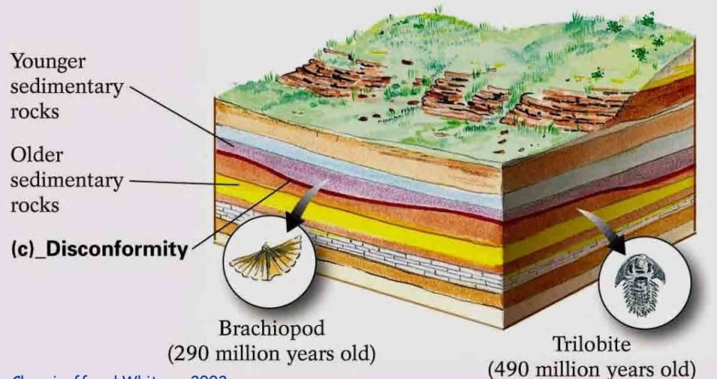**Disconformity:** A disconformity is an unconformity between parallel [layers](https://en.wikipedia.org/wiki/Stratum) of [sedimentary rocks](https://en.wikipedia.org/wiki/Sedimentary_rocks) which represents a period of erosion or non-deposition. Disconformities are marked by features of [subaerial](https://en.wikipedia.org/wiki/Subaerial" \o "Subaerial) erosion. This type of erosion can leave channels and [paleosols](https://en.wikipedia.org/wiki/Paleosols" \o "Paleosols) in the rock record.

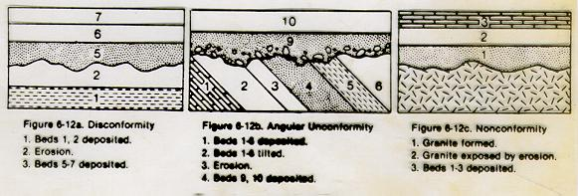A paraconformity is a type of disconformity in which the separation is a simple bedding plane with no obvious buried erosional surface.

**The Principle of Isostasy:** The principle of isostasy indicates that Earth’s crust floats in equilibrium with the denser mantle below, like an iceberg floats in water. If mountain ranges had no roots, a positive gravity anomaly would be expected, but such has not been observed. In contrast, no anomaly would be expected if they have roots. The buoyant force from extension of the low-density roots into the  
underlying high-density mantle causes mountains to stand high

Thick accumulation of sediment or glacial ice atop continental crust can push it lower into the mantle. Once the load is removed, the crust rises back to a position of equilibrium in a process known as isostatic rebound. Isostatic rebound affects mountain ranges. Due to isostatic rebound as  
mountains erode, progressively deeper levels are brought to the surface. If rebound continues long  
enough, only the plutonic and metamorphic rocks of the root will be left to record the existence of the former mountain range.